**Lab report no 3**



**Fall 2022**

# Control System Lab

**Submitted By**

**Name Registration No**

# Muhammad Ali 19pwcse1801

Section: **A**

**Date**: 11,08,22

**Submitted to: Dr Muniba Ashfaq**

Department of Computer Systems Engineering

University of Engineering and Technology, Peshawar

**Objectives: -**

* To understand stable, unstable, marginally stable LTI system.
* To learn how to find stability of system.
* And to practice the following in Simulink also.

**Task no 1: -**

Stable LTI system, system which has pole in the left side of the plane.

**Code: -**

clc

clear all

close all

%initial values for d/f function

p=[1 2 5];

%unstable system den = [-1 2 1]; nom = [1 2 5];

den = [1 0 1];

nom = [1 2 4];

%stable system den = [5 4 2]; nom = [1 2 5];

%marginally stable system den = [1 0 1]; nom = [1 2 4];

%finding roots

r=roots(p);

%finding poly

p=poly(r);

%finding transfer function

transfer_fuc = tf(nom,den);

%finding pzmap

pzmap(transfer_fuc);

%finding step step(transfer_fuc);

**Stable: -**

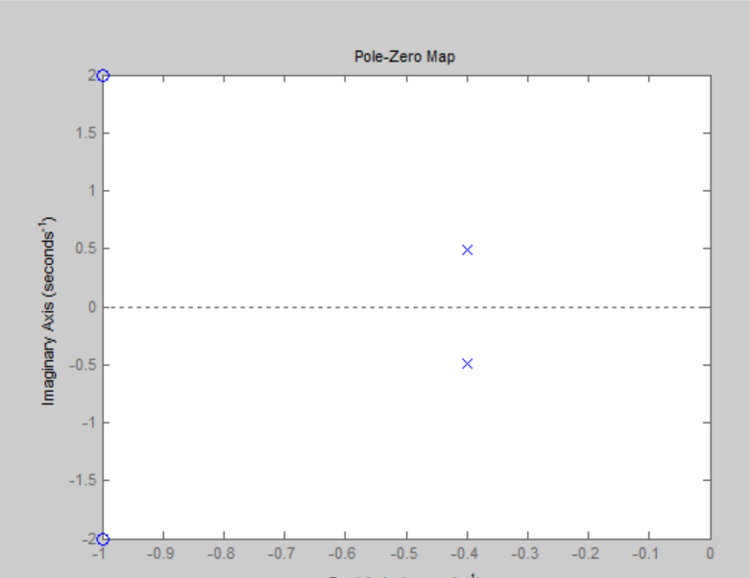

**Task no 2: -**

Unstable LTI system, the system which has at least one pole in the right side of the plane.

**Code: -**

den = [-1 2 1];

nom = [1 2 5];

r=roots(p);

p=poly(r);

transfer_fuc = tf(nom,den);

pzmap(transfer_fuc);

**Unstable: -**

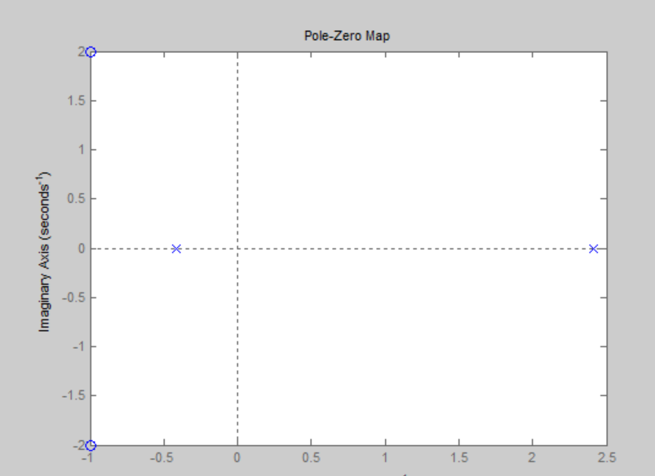

**Task no 2: -**

Marginally LTI system, the system which is neither stable nor unstable and has pole on the vertical axis of the plane.

**Code: -**

den = [-1 2 1];

nom = [1 2 5];

r=roots(p);

p=poly(r);

transfer_fuc = tf(nom,den);

pzmap(transfer_fuc);

Marginally stable: -

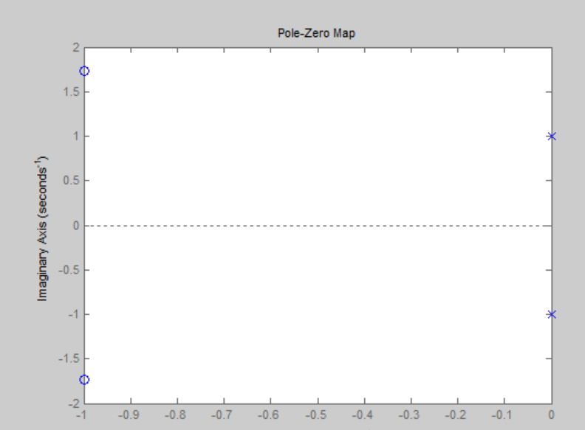

**Simulink: -**

**Stable: -**

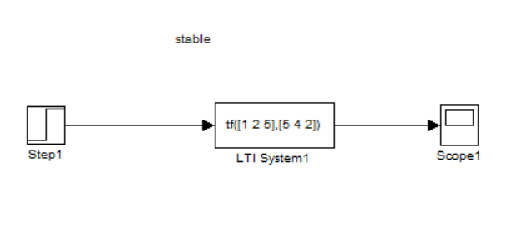

**Scope: -**

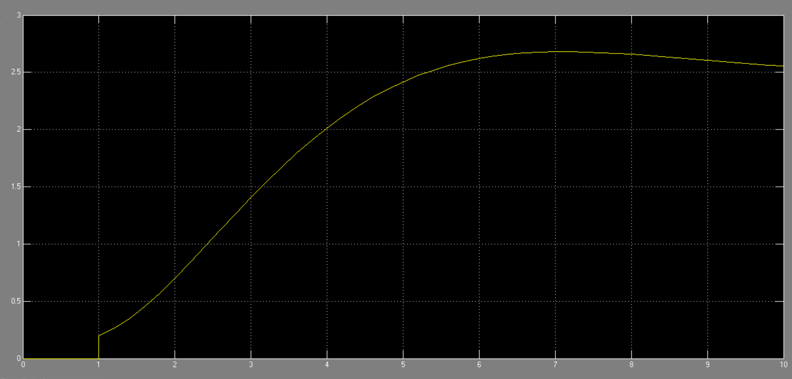

**Unstable: -**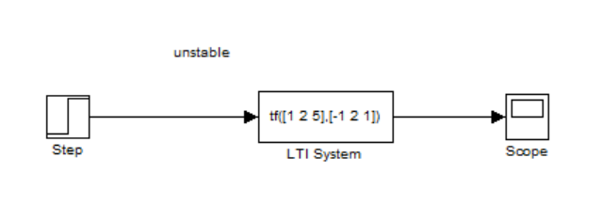

**Scope: -**

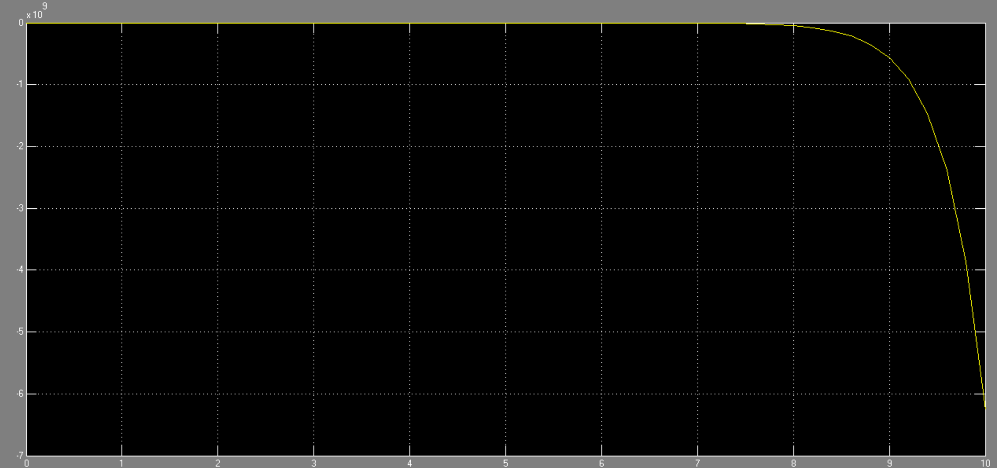

**Marginally stable: -**

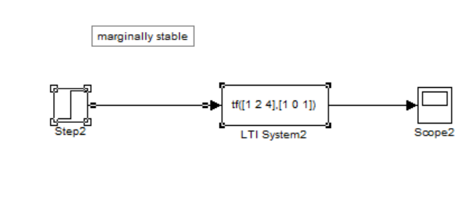

**Scope: -**

